**Selection Practice Problems with if & else**

1. Write a program that reads 5 Random 3 Digit values and then outputs the minimum and the maximum value.

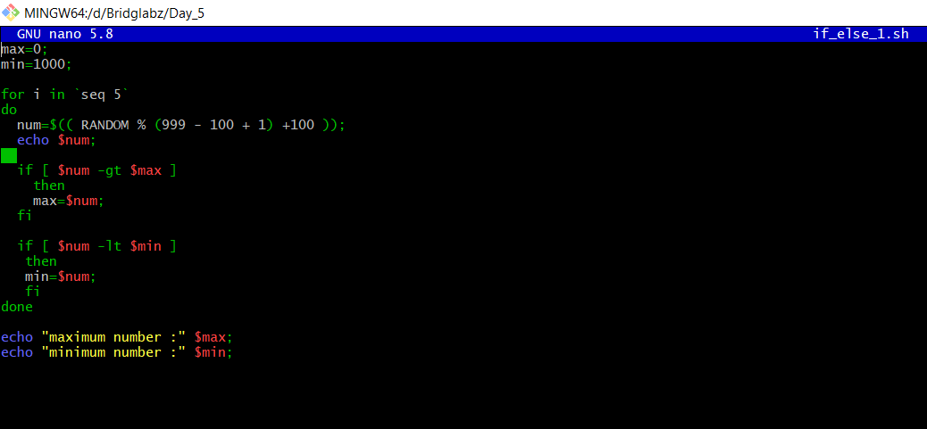

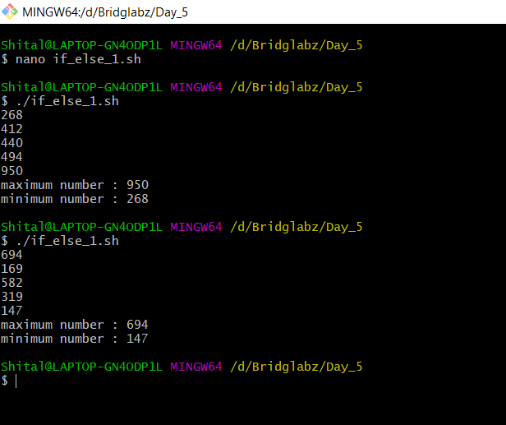

1. Write a program that takes day and month from the command line and prints true if day of month is between March 20 and June 20, false otherwise.

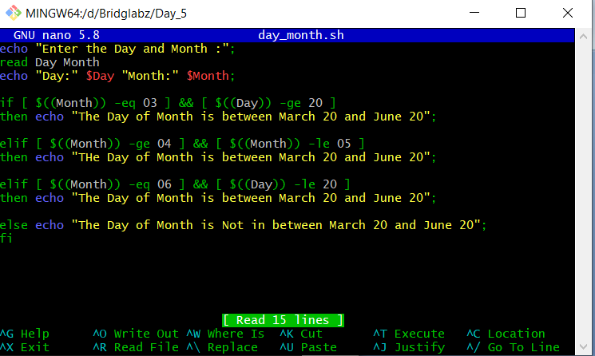

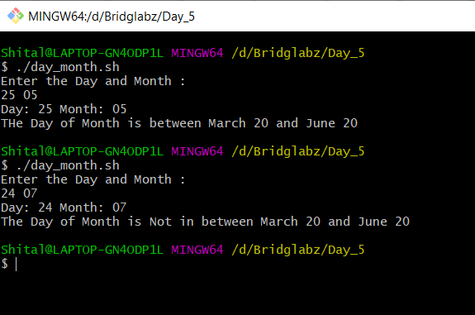

3. Write a program that takes a year as input and outputs the Year is a Leap Year or not a Leap Year. A Leap Year checks for 4 Digit Number, Divisible by 4 and not 100 unless divisible by 400.

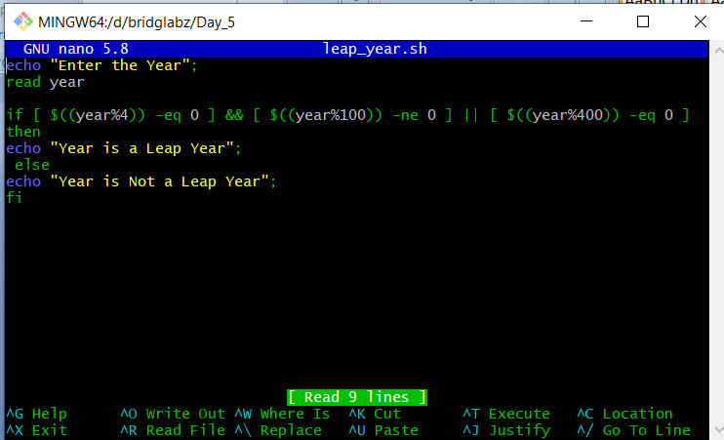

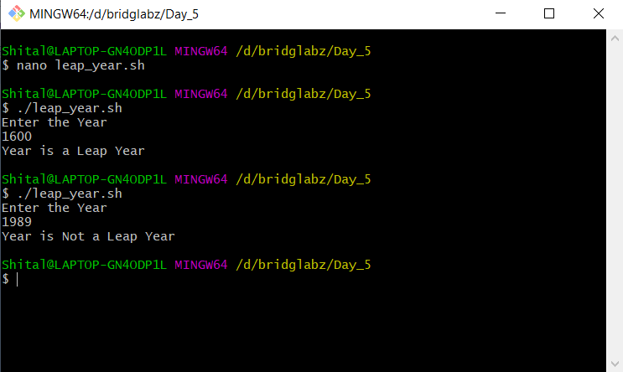

4. Write a program to simulate a coin flip and print out "Heads" or "Tails" accordingly.

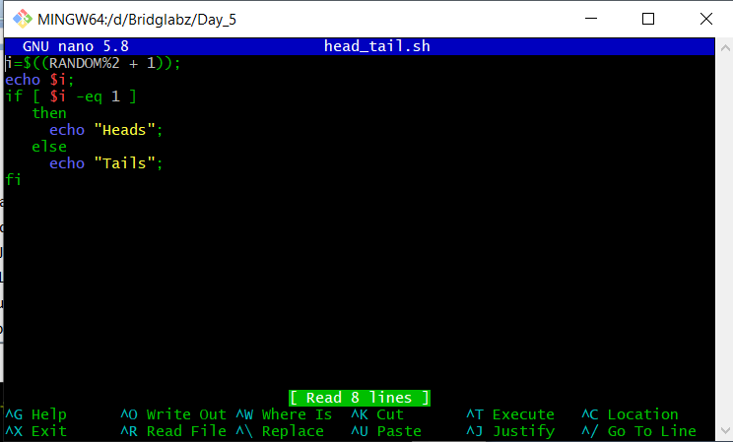

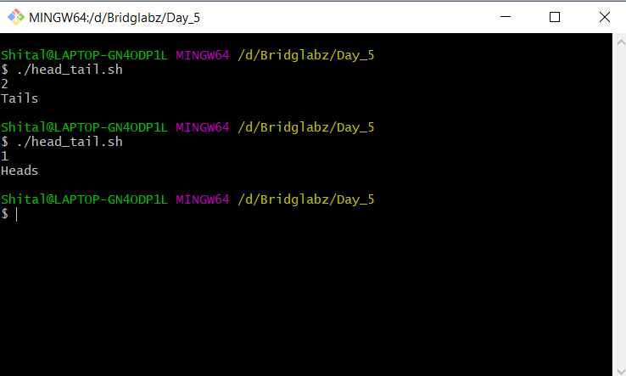

**Selection Practice Problems with if, elif and else**

1. Read a single digit number and write the number in word.

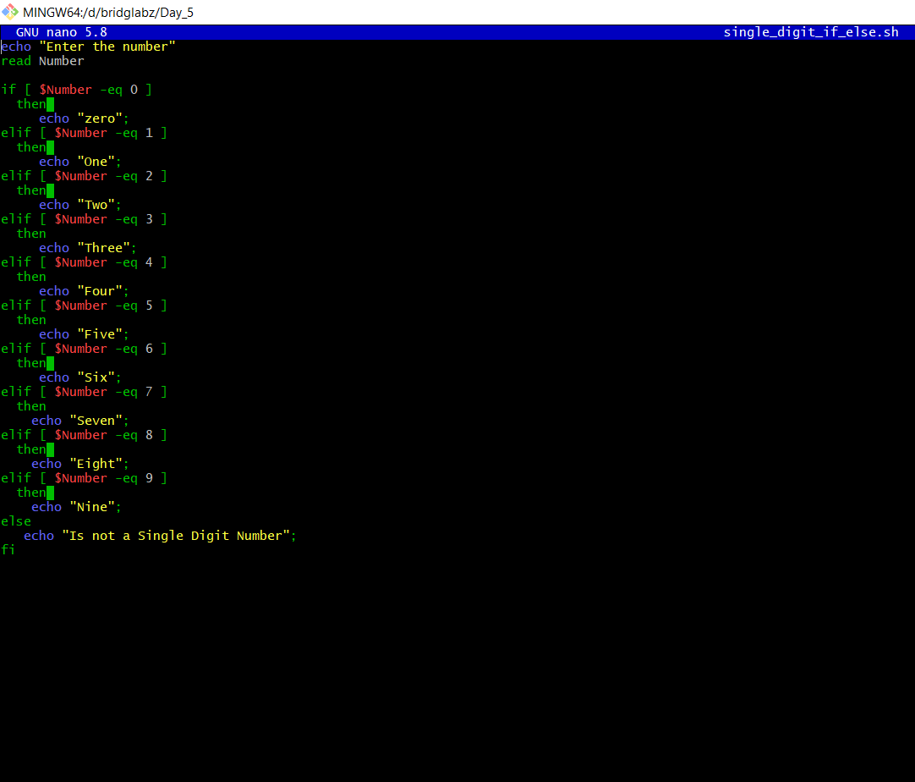

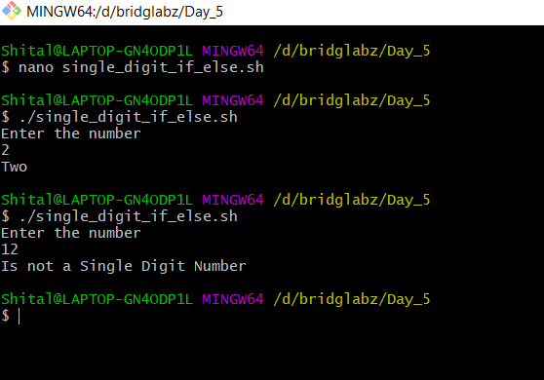

2. Read a Number and Display the week day (Sunday, Monday,…)

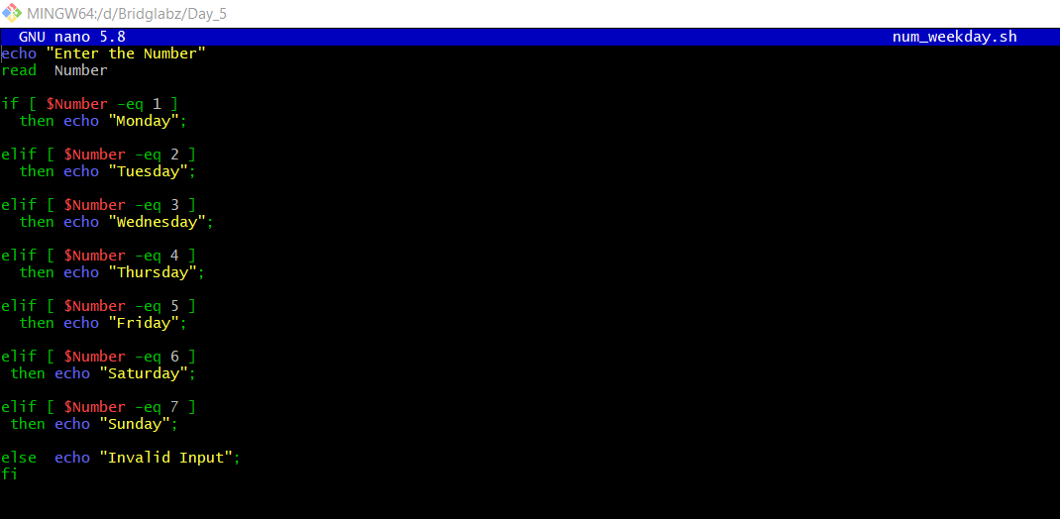

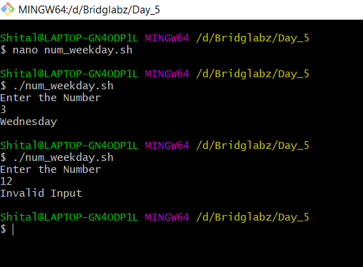

3.Read a Number 1, 10, 100, 1000, etc and display unit, ten, hundred,…

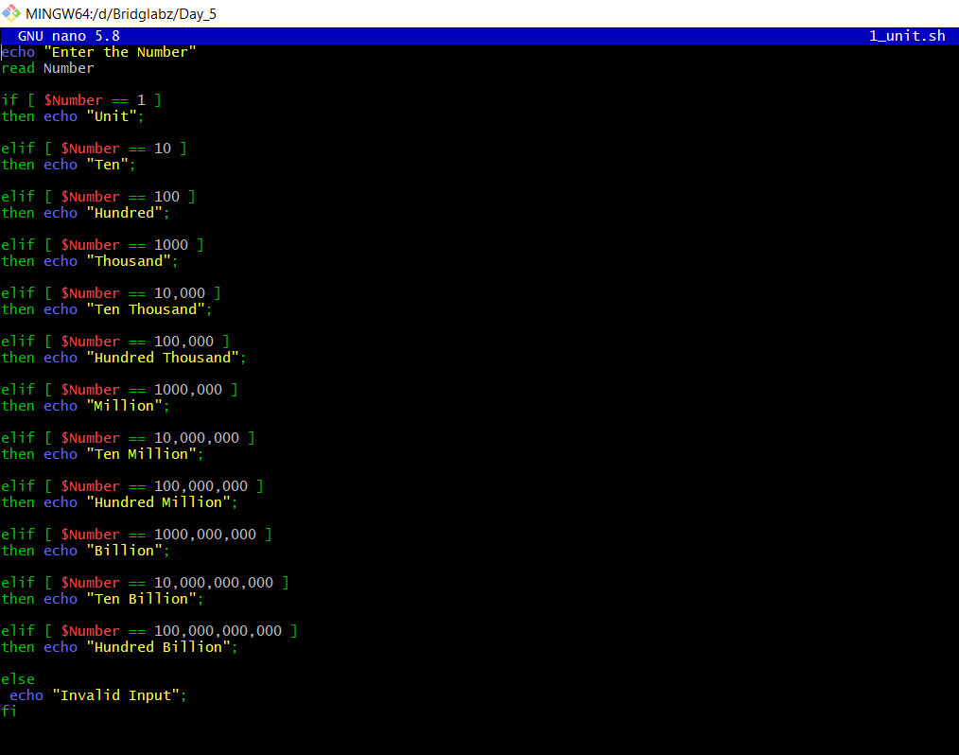

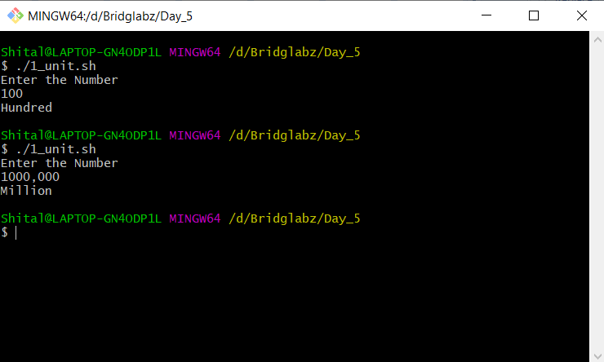

1. Enter 3 Numbers do following arithmetic operation and find the one that is maximum and minimum

1. a + b * c 3. c + a / b

2. a % b + c 4. a * b + c

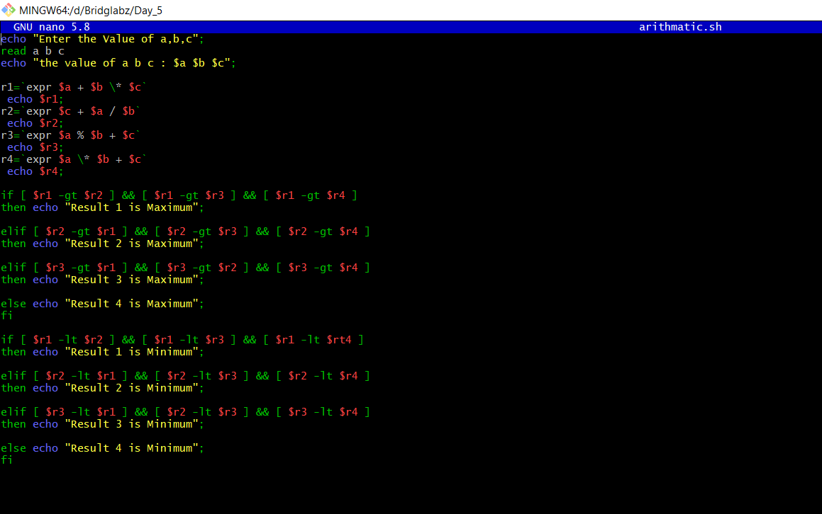

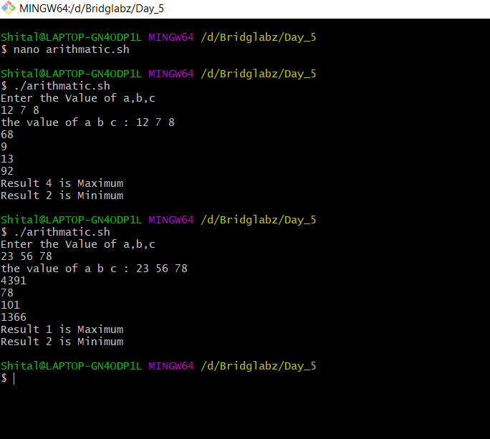

**Selection Practice Problems with case statement**

1. Read a single digit number and write the number in word using Case.

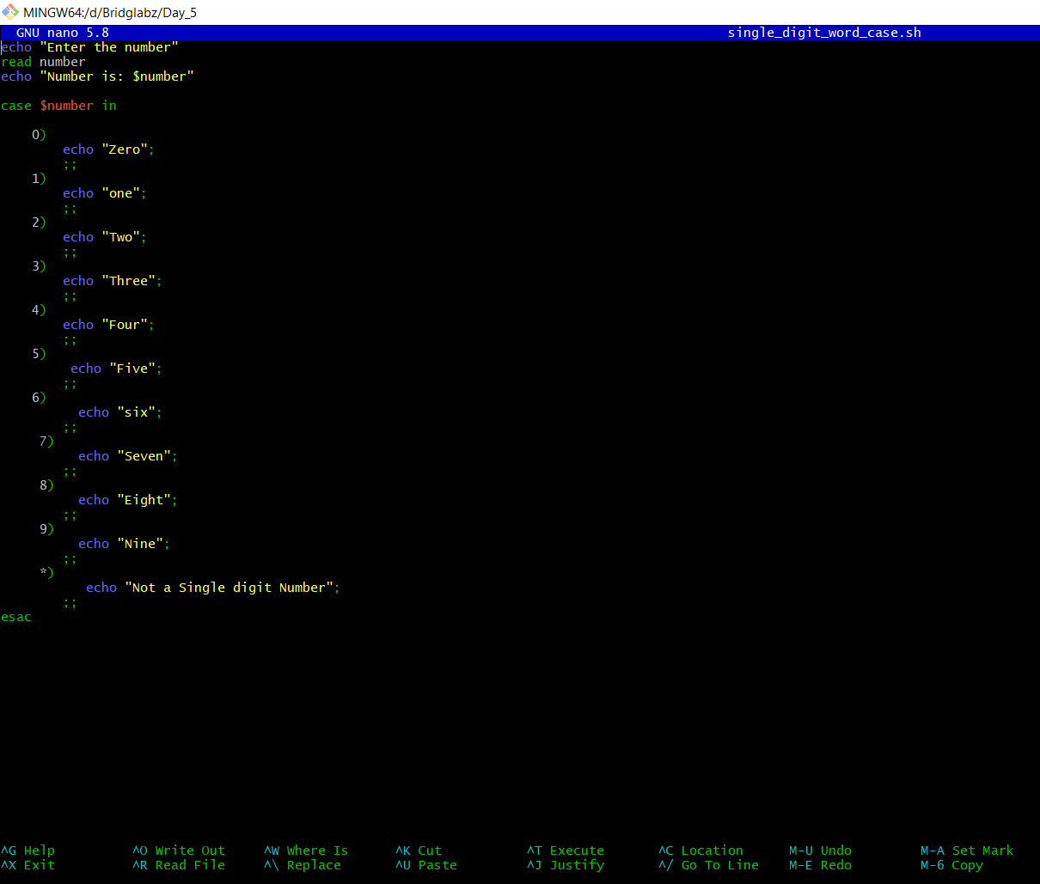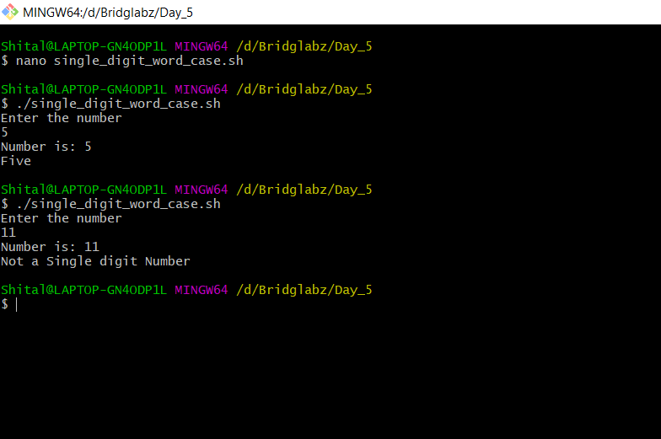

2. Read a Number and Display the week day (Sunday, Monday,…)

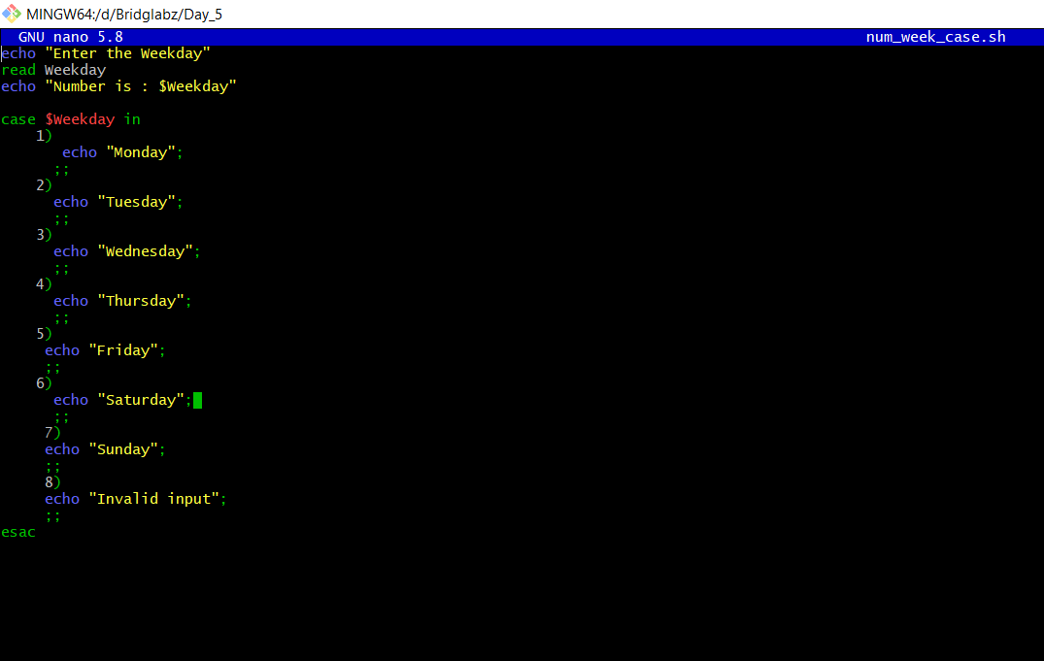

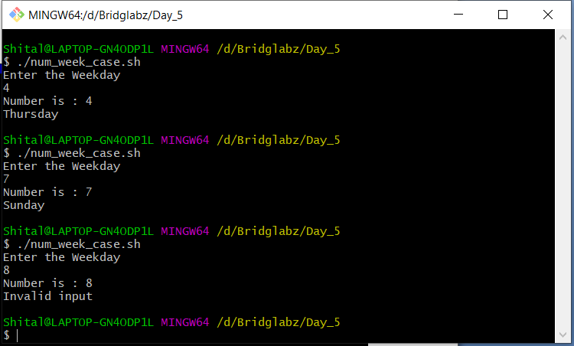

3. Read a Number 1, 10, 100, 1000, etc and display unit, ten, hundred,…

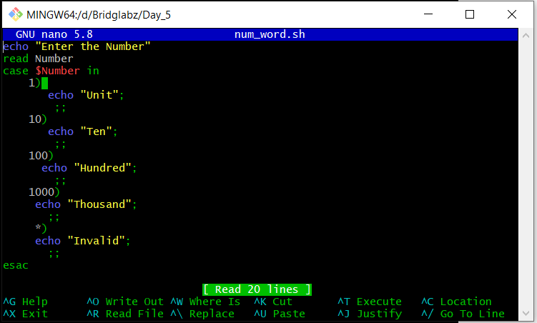

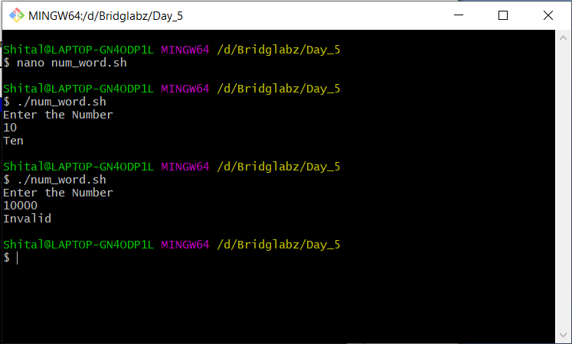

4. Write a program that takes User Inputs and does Unit Conversion of different Length units

1. Feet to Inch 3. Inch to Feet

2. Feet to Meter 4. Meter to Feet

